Adv AI Airbnb Prices Insights

Prices are rising every quarter
- Mean price rises from $196 → $212 (Oct 2022 → Jul 2023)
Median rises from $135 → $149
- This shows clear upward momentum in LA Airbnb prices.

The market size is growing
- Listings rise from 39k → 43k+
- That means LA hosted more Airbnb supply in 2023 than in late 2022

Entire homes are most expensive
- Average price ~ $240 → $253 per night.

Hotel rooms are much cheaper
- Around $148.

Entire homes show a rising trend until Q2 2023
- Slight dip in Q3 might reflect seasonality or increased supply.

Prices are increasing by ~$5.42 every quarter
- This is the trend signal.
- Quarterly growth = +$5.42, Annualized growth ≈ +$21.7 per year

Airbnb prices in LA are rising steadily each quarter
- The linear trend model found:
- Slope (increase per quarter): +$5.42
- Intercept (baseline starting point): ~$196
LA Airbnb prices are increasing by about $5–6 per quarter, or ~$22 per year. This is a moderate, stable upward trend.

Visualizations:
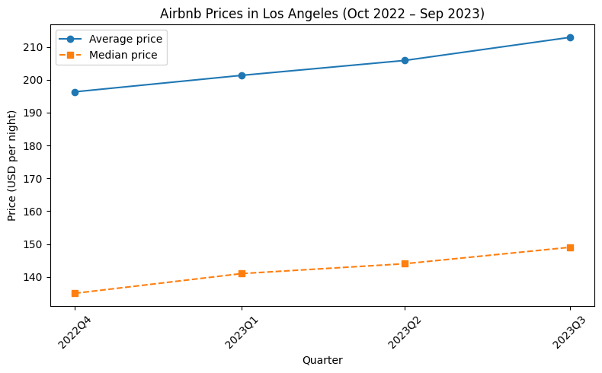
- Airbnb prices in Los Angeles increased steadily from Oct 2022 to Sep 2023.
- The average price rose by 8.1% and the median price by 10.3%, indicating broad-based price growth across the market.
- Summer 2023 shows the highest price levels, consistent with seasonal demand patterns.
- Both mid-range and premium listings are becoming more expensive, suggesting sustained post-COVID recovery in LA’s short-term rental market.

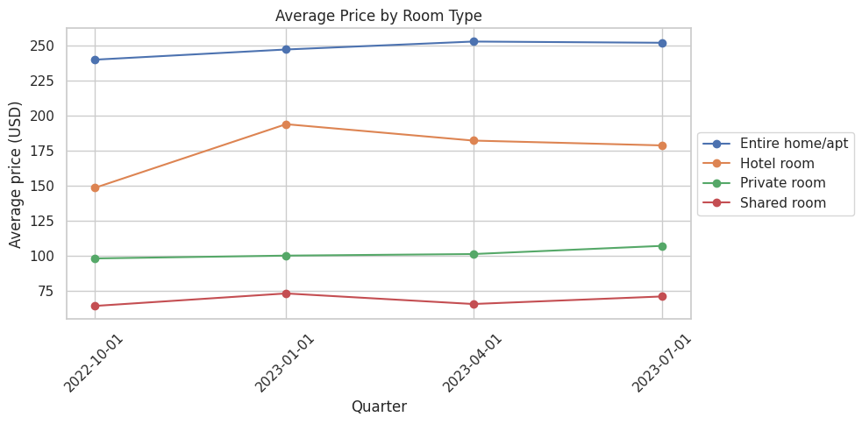
- Entire homes drive the high end of the LA Airbnb market, hotels show strong seasonal swings, and private rooms remain stable and affordable, reflecting clear segmentation in traveler demand.

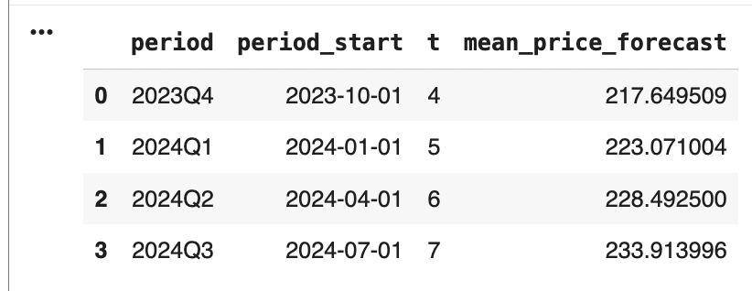
- Prices will likely continue rising, but gradually.
- By next summer, average prices could reach ~$234, up from ~$212 today.
- This pattern reflects stronger tourism, inflation, and sustained demand for short-term rentals.

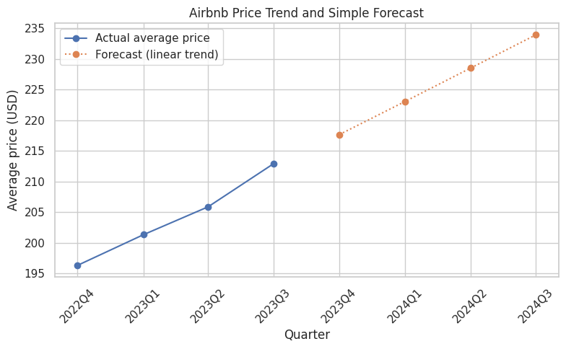
- Using a linear trend model on quarterly average prices, we find that Airbnb prices in LA are rising by approximately $5.42 per quarter, or $21.7 per year.
- Our forecast projects that average nightly prices will increase from $212 in 2023Q3 to approximately $234 by 2024Q3.
- This trend suggests continued post-COVID recovery, increasing tourism demand, and upward pricing pressure in the LA short-term rental market.

ARIMA Forecast:

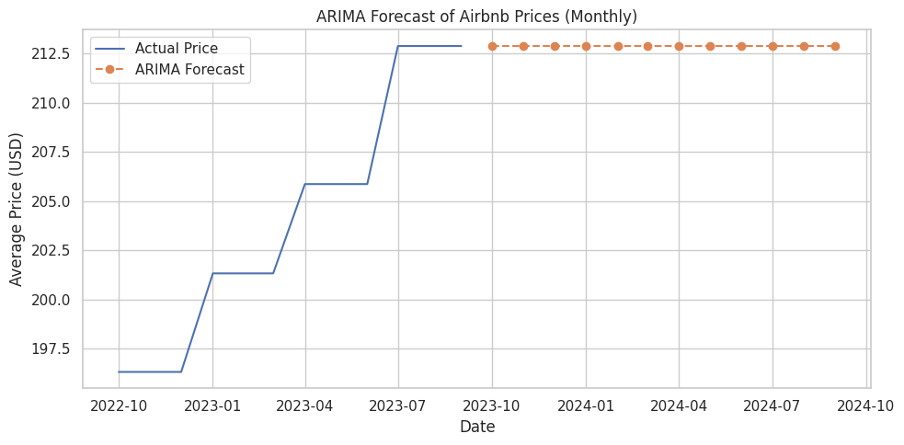
- We tested an ARIMA(1,1,1) model to produce a more sophisticated time-series forecast.
- Because we only have 12 monthly data points, the ARIMA model does not detect a reliable trend and therefore produces a nearly flat forecast.
- This is expected behavior with small samples, and it reinforces that the linear trend model is more appropriate for this dataset.

SARIMA Forecast:
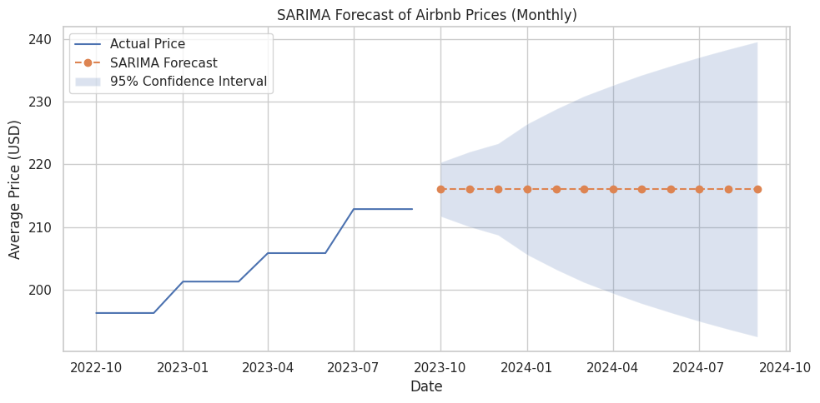

- Tested a SARIMA model with quarterly seasonality.
- Because our monthly time series is short (12 observations), SARIMA produces a conservative, flat forecast centered around $216 and a wide confidence interval.
- This behavior is expected with small samples: SARIMA avoids over-fitting and instead reports stable expected values with growing uncertainty.
- Importantly, SARIMA’s central forecast does not contradict our linear trend, it simply expresses that the model needs more data to learn seasonality.

